|  |  |
| --- | --- |
| DeSIGN DOCUMENT  Mikaeil Shaghelani Lor – jiefan lin-Wen Li | ei8s2 | group 3  Class diagram-Description of the classes and their members along with Some sequence diagrams.  **MDW- Heroes of the storm**  18/May/2016 V1.0.0 |

1. **Table of Contents**
2. Table of content-------------------------------------------------------------1
3. Introduction------------------------------------------------------------------2
4. Class Diagrams--------------------------------------------------------------4
5. Description of classes--------------------------------------------------5-7
6. Interactions /Some sequence diagrams-----------------------------8-13

# User Interface

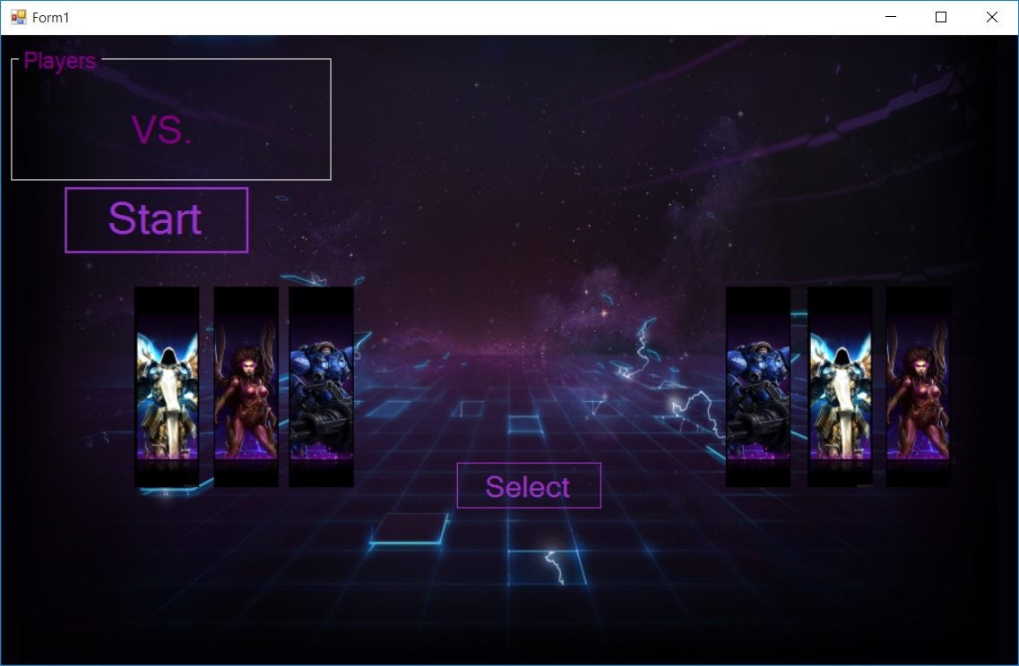

Figure 2.a

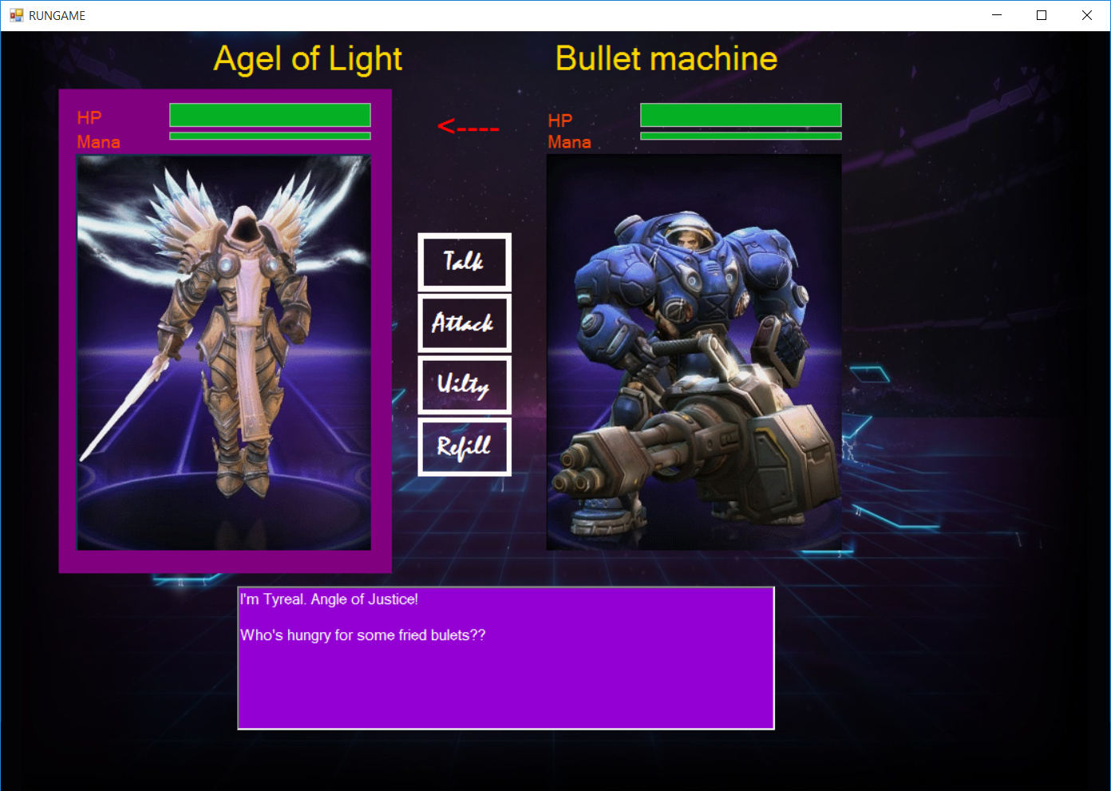

Figure 2.b

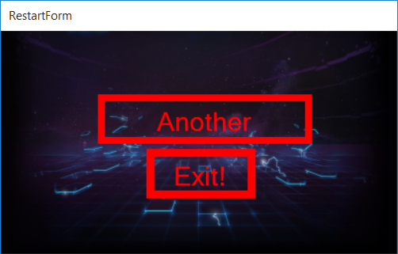

**Heroes of the storm**

Purpose

This design document describes the architecture and system design of our game along with elaborating the entities, attributes and their relations in respect to how they could be used to develop this program most efficiently in order to have a real game that user can enjoy playing it.

1. Scope

The objective and the goal of this product is to building a game and mae use of distributed system and WCF technology.

In this design document we provide description of our high level entities among with some design visualizations such as **class diagrams** and few of the most important **sequence diagram**s ,which would explain the interactions for some specific set of actions.

1. **Class diagram**

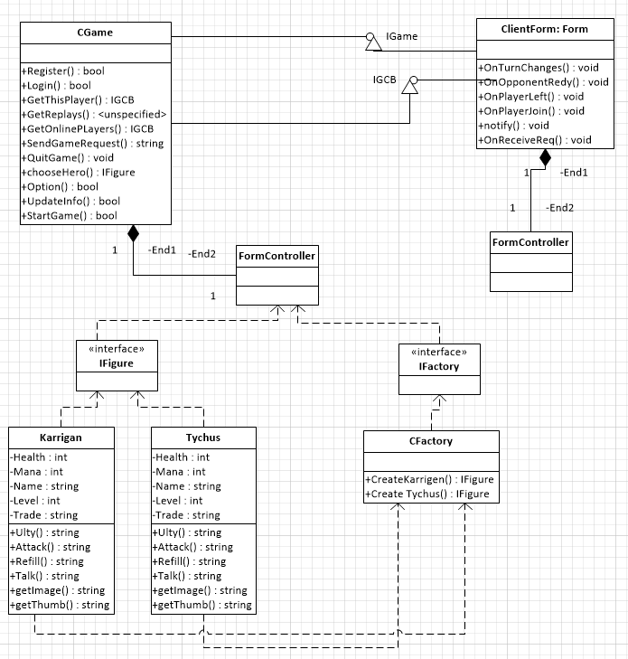

***Figure 3.1***

1. **Description of the classes and their members**

**Server Side:**

* IGame
* CGame
* FormController
* ServerForm
* IGCB
* IFigure
* IFactory
* Kerrigan, Tyrael, Tychus, …. (Implements IFigure)
* CFactory

**Client Side:**

* ClientForm
* FormController

**Class Members description see figure 3.1**

# Interface IGame

This interface is our contract with users so it needs to have all the functionality and operations that we want to expose to the world.

# Class CGame

This class is implementing the IGame interface and included all operations that is available to the user. This is our game endpoint for users and make Registration, Login, ChooseHero, etc possible.

# FormController

For better structure of code and keep the forms as clear as possible we have this formController to help us with the communications between form and other classes.

# IGCB

This interface is the communication way from server to our users. It needs to be implemented by the Client and have all the necessary operation when an event occurs that the user needs to be notified.

**Our game like other combat games has a number of superheroes that are available to play for this part of server we make use of “Abstract Factory” pattern to implement it.**

# IFigure

This interface is the sample for our all superheroes. And it has all the attribute and operations that are necessary.

# Karrigan,Tyrael,Tychus, etc.

These are our Concrete classes that are going to implement IFigure interface, each one in a different way,

# IFactory

This interface is one solid place for creating instance of all the figures.

# CFactory

This concrete factory class is responsible for generating all the heroes and have different methods to finish its job.

# ClientForm

This form needs to make use of the endpoint supplied by the server and consume all it operations and needs to implements IGCB interface and expose it to server.

# FormControllers

For better structure of code and keep the forms as clear as possible we have this formController to help us with the communications between form and other classes.

1. **Interactions/sequence diagrams**

**User Registeration**

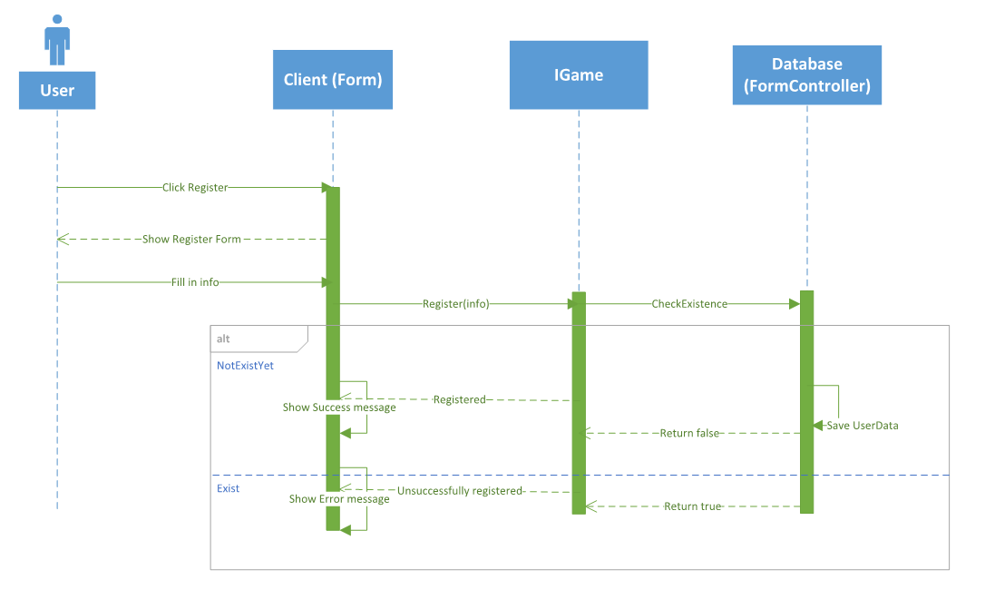

***Figure 5.1***

* In Figure 5.1 the sequence diagram shows how a user can register

**User Login**

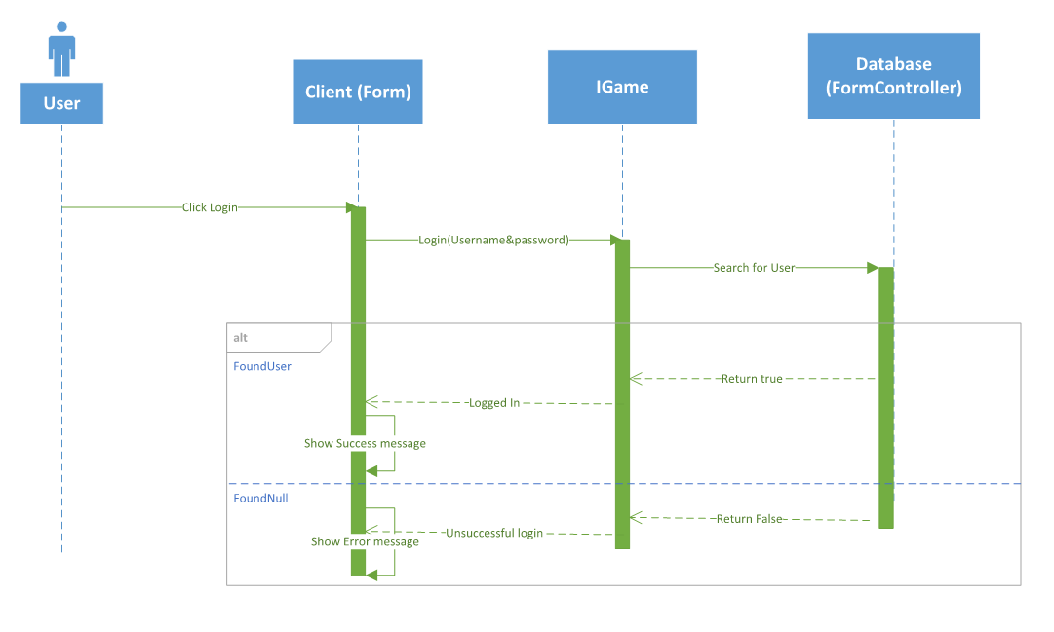

***Figure 5.2***

* Figure 5.2 the sequence diagram shows how a user can login

**User Edit Profile**

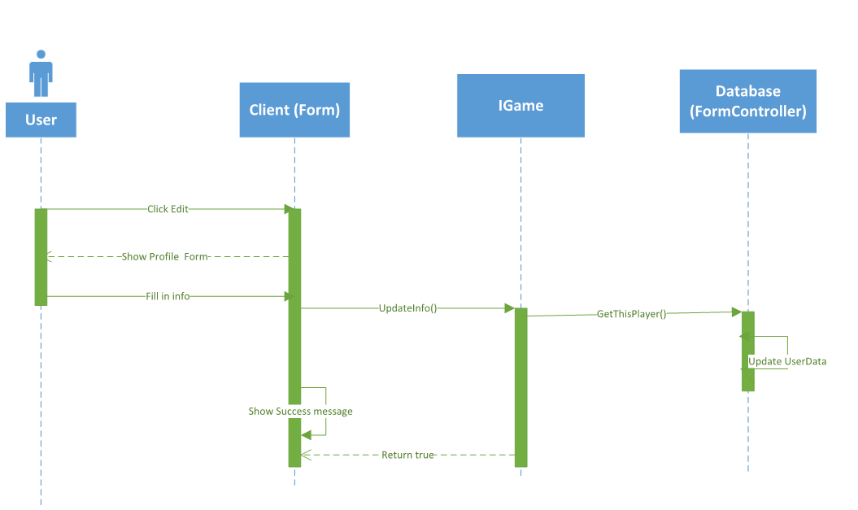

***Figure 5.3***

* Figure 5.3 the sequence diagram shows how a user can edit its information

**Multiplayer**

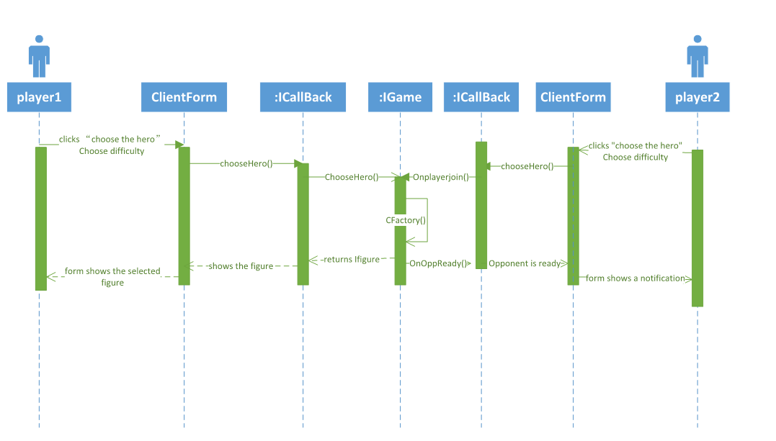

***Figure 5.4***

* Figure 5.4 the sequence diagram shows how a user can play multiplayer

**SinglePlayer**

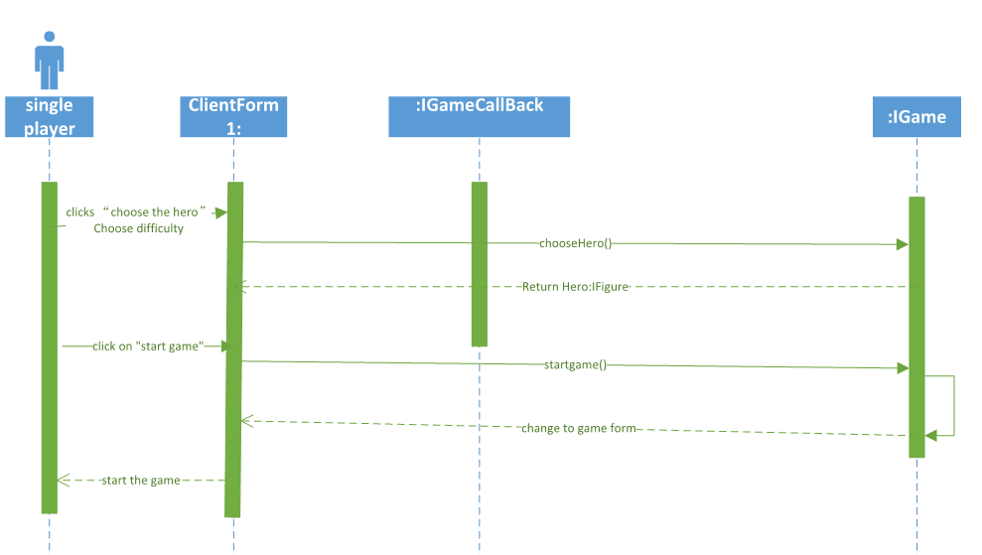

***Figure 5.5***

* Figure 5.5 the sequence diagram shows how a user can play multiplayer

**Quit Game**

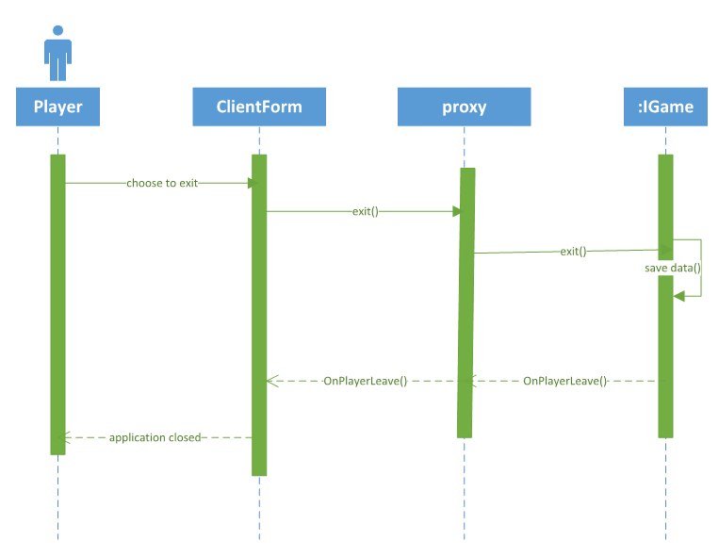

***Figure 5.6***

* Figure 5.6 the sequence diagram shows how a user can quit game